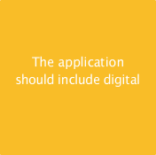

calendar

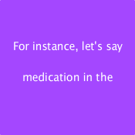

you have to take morning

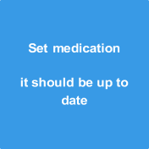

**reminders once and**

***Loganathan M***

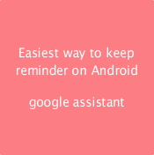

phone is to use



simple to use

**watch or other wearable**

walk, etc.

***Saran pandi M***

***Sivakumar S***

**devices should be**

Emergency contact

blind people)

appointments

***Santhoshkumar K***

**It should remind the time**

**Application should be**

***Yogeshwaran M***